

American International University-Bangladesh (AIUB)  
**Department of Computer Science  
Faculty of Science & Technology (FST)**

**Section: C  
Project Title: Smart Traffic Control System**

Supervised By

## Prof. Dr. Kamruddin Nur

A Software Engineering Project Submitted By :

|  |  |  |  |  |
| --- | --- | --- | --- | --- |
| **Semester: Summer_21_22** | | **Section:** | **Group Number:** | |
| SN | Student Name | Student ID | Contribution (CO3+CO4) | Individual Marks |
| 01 | Riad Al Hasan | 22-46732-1 |  |  |
| 02 | Aishee Debnath | 22-46416-1 |  |  |
| 03 | Sakif khan | 22-46425-1 |  |  |

The project will be Evaluated for the following Course Outcomes

|  |  |  |
| --- | --- | --- |
| **CO3:** *Select* appropriate software engineering models, project management roles and their associated skills for the complex software engineering project and evaluate the sustainability of developed software, taking into consideration the societal and environmental aspects | Total Marks | |
|  | |
| Appropriate Process Model Selection and Argumentation with Evidence | [5 Marks] |  |
| Evidence of Argumentation regarding process model selection | [5Marks] |  |
| Evaluate the sustainability of the developed software in terms of both society and the environment (Impact identification) | [5Marks] |  |
| Submission, Defense, Completeness, Spelling, grammar and Organization of the Project report | [5Marks] |  |
| **CO4:** *Develop* project management plan to manage software engineering projects following the principles of engineering management and economic decision process | Total Marks | |
|  | |
| Develop the project plan, its components of the proposed software products | [5Marks] |  |
| Identify all the activities/tasks related to project management and categorize them within the WBS structure. Perform detailed effort estimation correspond with the WBS and schedule the activities with resources | [5Marks] |  |
| Identify all the potential risks in the specific project and prioritizing/categorizing those to overcome the risk factors. | [5Marks] |  |

**Table of Content**

|  |  |  |
| --- | --- | --- |
| SL No | Topic | Page No |
| 01 | Project Work Contributions | 3 |
| 02 | Description | 5 |
| 03 | Proposed Problem | 5 |
| 04 | Proposed Solution | 5 |
| 05 | Process Model | 6 |
| 06 | Project Role Identification and Responsibilities | 6 |
| 07 | WBS diagram | 7 |
| 08 | Project Risk | 8 |
| 09 | Project Requirement | 9 |
| 10 | Use Case Diagram | 10 |
| 11 | Prototype Design | 11 |
| 12 | User Interface Diagram (UI) | 12 |
| 13 | Project Risk Management | 13 |
| 14 | Project Testing | 14 |
| 15 | Maintenance Plan | 15 |
| 16 | Conclusion | 16 |

|  |  |
| --- | --- |
| Final Term Part | |
| 01 | User Interface Diagram (UI) |
| 02 | Project Risk Management |
| 03 | Project Testing |
| 04 | Maintenance Plan |

**Description of Student’s Contribution in the Project work**

|  |
| --- |
| Student Name: Riad Al Hasan  Student ID: 22-46732-1  Contribution in Percentage (35%):  Contribution in the Project:   * Developed project proposal and description. * Identified project problem and proposed solutions. * Created the Gantt chart for project planning. * Wrote and tested code for various functionalities. * Adjusted design for particular things. * Ensured functional requirements and security measures. * Developed modules for Fine Payment and Compliance, Public Transportation Management, and Driver Information System. * Conducted unit and system testing. * Monitored performance throughout the project lifecycle. * Project Risk Management Analysis   ___________________  Signature of the Student |
| Student Name: Aishee Debnath  Student ID: 22-46416-1  Contribution in Percentage (33%):  Contribution in the Project:   * Defined project scope and time limitations. * Created the Use Case diagram. * Managed project execution. * Collected data requirements. * Developed modules for Traffic Monitoring and Signal Optimization, Urban Planning, and Data Aggregation. * Conducted User Acceptance Testing. * Maintenance Plan * Testing * Collected and incorporated user reviews.   ___________________  Signature of the Student |
| Student Name: Sakif khan  Student ID: 22-46425-1  Contribution in Percentage (32%):  Contribution in the Project:   * Planned the project and created the Work Breakdown Structure (WBS) diagram. * Monitored project progress and managed closing tasks. * Developed modules for Traffic Officer Support System, Violation Detection and Enforcement, and Emergency Vehicles Priority. * Conducted integration testing. * Managed system updates.   sakif  _________________  Signature of the Student |

**Project Proposal: Smart Traffic Control System**

**Project Description:** The Smart Traffic Control System tackles urban issues like congestion, lack of real-time information, inefficient public transport, traffic violations, and inadequate urban planning data. Using IoT sensors and high-resolution cameras at key intersections, the system will monitor traffic and dynamically adjust signal timings to reduce congestion, especially during peak hours.This software will provide drivers with real-time traffic updates, alternative routes, and information on traffic regulations and weather conditions. Traffic officers will use a centralized dashboard and app for real-time alerts and incident reporting.The software will improve public transportation with real-time schedule updates and GPS tracking for better reliability and efficiency. Automated violation detection system will enhance compliance and safety, while comprehensive traffic data will support data-driven urban planning.To facilitate fine compliance, the system will offer multiple convenient payment methods and robust tracking mechanisms. Overall, the Smart Traffic Control System aims to revolutionize urban mobility, creating safer, more efficient, and sustainable urban environments.

**Background to the problem:**

* **Traffic Congestion:** High vehicle density, inefficient signal timings, unplanned road networks.
* **Lack of Information for Drivers and Officers:** Drivers and traffic officers lack real-time data on traffic conditions, rules, and violations.
* **Inefficient Public Transportation:** Unreliable schedules, lack of coordination.
* **Traffic Violations:** Frequent rule-breaking, insufficient enforcement.
* **Urban Planning Data Deficiency:** Lack of comprehensive traffic data.
* **Emergency Vehicle Delays:** Delays in critical services due to traffic.
* **Challenges in Payment Collection:** Inconvenient methods, low compliance.

**Solution to the problem:**

* **Real-Time Traffic Monitoring:** IoT sensors and cameras at key intersections to monitor and adjust traffic signal timings dynamically.
* **Driver Assistance:** Softare providing real-time traffic updates, alternative routes, and information on rules and conditions.
* **Traffic Officer Support:** Softare website and centralized dashboard for real-time alerts and incident management.
* **Public Transport Enhancement:** Real-time schedule updates, GPS tracking, and optimized schedules.
* **Automated Violation Detection:** Software algorithm to detect and report violations, maintaining a centralized database.
* **Data-Driven Planning:** Aggregation and analysis of traffic data for better urban planning.
* **Emergency Vehicle Priority:** Adjusting signals to prioritize emergency vehicles.
* **Efficient Fine Payment System:** Multiple payment methods and robust tracking for fines.

**Main goal of our project:**

* Alleviate traffic congestion during peak hours.
* Provide real-time, actionable information for drivers and traffic officers.
* Improve public transport reliability and efficiency.
* Ensure compliance with traffic laws through automated enforcement.
* Support data-driven urban planning.
* Facilitate convenient fine payment processes.

**SOFTWARE DEVELOPMENT LIFE CYCLE**

**Process Model**

The Smart Traffic Control System is a complex and dynamic project that needs real-time data processing and continuous updates.Here,we are used mothod was **Agile Methodology**. Below the details for the reason why we are uses this method-

* **Flexibility and Adaptability:** Urban traffic is unpredictable with constant changes. Agile's iterative approach allows the team to quickly adapt to new requirements and feedback in short cycles.
* **Incremental Development:** Agile breaks the project into small, manageable parts (sprints).
* **Stakeholder Collaboration:** Agile ensures their input is considered throughout the development process with regular meetings and reviews.
* **Continuous Testing and Integration:** Agile includes testing in every sprint, making sure each part works well before moving on.
* **Risk Management:** Agile's iterative nature helps identify and address potential issues early.

**Project Role Identification and Responsibilities**

* **Project Manager:** The Project Manager oversees the entire project lifecycle, managing timelines, coordinating team efforts, allocating resources, and ensuring adherence to budget constraints.
* **Product Owner:** The Product Owner serves as the main link between stakeholders and the development team, defining the project vision, prioritizing tasks, and ensuring that development meets user requirements and business objectives.
* **Development Team:** Design, code, and test the software. Develop features based on the product backlog and ensure the software meets the required specifications and quality standards.
* **Designer:** Design user interfaces and experiences that are intuitive and user-friendly. Create wireframes, prototypes, and visual designs.
* **Testing Engineer:** Develop and execute test plans and test cases to ensure the software is free of defects and meets quality standards.
* **Systems Analyst:** Understand user needs and translate them into technical requirements for the development team.
* **Maintainance Team:** Provide ongoing support and maintenance for the software.

**Work Breakdown Structure (WBS) diagram**

**Project Risk:**

**Project Requirement**: The project requirements for the Smart Traffic Control System, we will categorize them into functional and non-functional requirements

**Functional Requirements**

* **Real-Time Traffic Monitoring** using IoT sensors and high-resolution cameras
* **Driver Assistance:** Software that gives real-time traffic updates, alternative routes, and information on traffic rules and conditions.
* **Traffic Officer Support:** Software for traffic officers to receive real-time alerts and manage incidents.
* **Public Transport Enhancement:** Real-time schedule updates and GPS tracking for public transportation vehicles.
* **Automated Violation Detection:** Software should detect and report traffic violations, enforcement and analysis automatically
* **Data-Driven Urban Planning:** Aggregate and analyze traffic data to support better urban planning decisions.
* **Emergency Vehicle Priority:** Adjust traffic signals to prioritize the passage of emergency vehicles.
* **Efficient Fine Payment System:** Software Provide multiple payment methods for fines and ensure robust tracking and enforcement of payments.

**Non-Functional Requirements**

* **Performance:** The software should process and respond to real-time data within milliseconds to ensure timely adjustments to traffic signals and updates to users with minimal latency.
* **Scalability:** Accommodate additional sensors, cameras, and users without performance degradation.
* **Security:** Protect user data and system operations from unauthorized access and cyber threats.
* **Reliability:** The software should have high availability with minimal downtime, ensuring continuous monitoring and control.
* **Usability:** The user interfaces for the software and traffic officer dashboard should be intuitive and user-friendly.
* **Maintainability:** The system will design with modularity to facilitate easy updates and maintenance.
* **Compliance:** Regularly update the system to adhere to any changes in regulations.
* **Compatibility:** Ensure seamless integration with third-party applications and services used by public transportation and traffic enforcement agencies.

**UseCase Diagram**

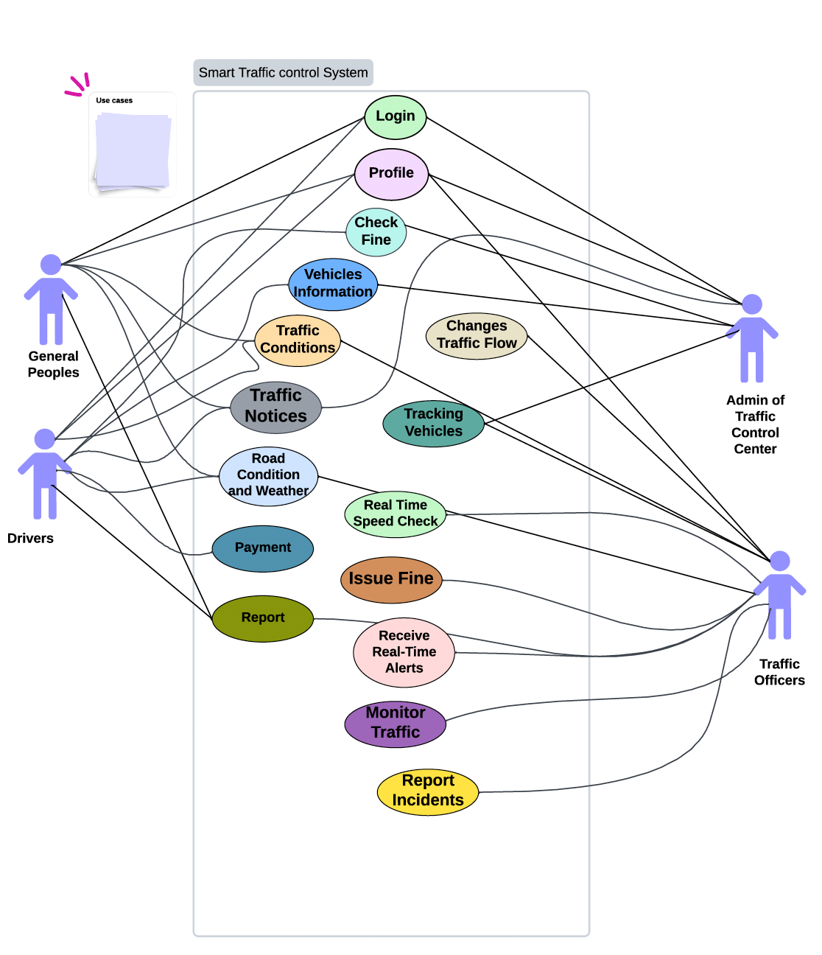

**Prototype Design**

**User Interface Diagram (UI)**

**Project Risk Management:**

**Project Testing:**

**Project Maintainance Plan:**

**Conclusion:**

In conclusion, the Smart Traffic Control System software has demonstrated significant advancements in urban traffic management, setting a benchmark for efficiency and safety. Its scalable architecture and proven results suggest potential software in diverse urban environments globally. This project not only addresses current traffic challenges but also lays a foundation for future innovations in smart city infrastructure.